**E-Commerce Website**

Mr. Nikhil Ramuji Gabhane

Department of Chemical Engineering

Abstract — E-commerce means electronic commerce. E-commerce involves buying and selling of products and services, or the transmitting of funds or data, over an system, predominantly the net. E-commerce could be a paradigm shift influencing both marketers and also the customers. Rather e-commerce is quite just differently to spice up the prevailing business practices. It’s leading to a whole change in the traditional way of doing business. This significant change in business model is witnessing an amazing growth round the globe and India isn't an exception. A large internet penetration has added to growth of E-commerce and more particularly start-ups are increasingly using this selection as a differentiating business model. Moreover E-Commerce has significant influences on the environment. Although the model is very employed in current business scenario but the choice has not been explored at its fullest. The present research and analysis has been undertaken to explain the condition of E-Commerce websites, analyze the trends of E-Commerce

***Keywords — E- Commerce Html, CSS, VR Studio***

# **INTRODUCTION**

E-Commerce is the process of doing business online through computer networks. The first goal of an ecommerce site is to sell goods and services online. Online shopping may be a type of electronic shopping store where the customer is directly online to the seller’s computer usually via the net. An individual sitting on his chair before of a computer can access all the facilities of the net to shop for or sell the products. Online Shopping System helps in buying of products, products and services online by choosing the listed products from website (E-Commerce site). The go-cart is especially useful for who haven’t time to travel to shopping. Go-cart may be a important feature employed in e-commerce to help people making purchases online. Buy and sale process is completed electronically or cash on delivery. User can login into e-Commerce website, once he logged in then automatically one go-cart are going to be created, once user select an item it'll increase cart. Just in case user thinks the chosen item isn't useful for him, then he can delete that item form the cart. Report generation feature is provided using Crystal Reports to come up with different styles of reports like bar graphs, pie charts and table type charts etc. The proposed system helps in building an internet site to shop for, sell products or goods online using internet connection. Unlike traditional commerce that's distributed physically with effort of an individual to travel and find products, e-Commerce has made it easier for human to scale back physical work and to avoid wasting time.

**2. LITERATURE SURVEY**

Internet has major influence on the globe because it can serve billions of users all over the world. Thousands of local and global networks including private, public, academic, business, and government networks, all contribute to the creation of the Internet. Internet has opened the door for e-commerce. This section provides a brief overview of e-commerce, including what it is and how it differs from existing related ideas. The use of e-commerce is growing as a way to conduct business. The initial phase of conducting research regarding e-commerce is to explain the e-commerce idea.

There are many types of e-commerce, but the most common are as follows:

• B2B (Business-to-Business):

B2B involves trade dealings between businesses where sale of merchandise is made to an interim purchaser. B2B e-commerce deals with interactions between and among businesses. About 80% of e-commerce is in this category. One example of B2B is a business transaction between a manufacturer and a wholesaler, or between a wholesaler and a retailer.

B2C (Business-to-Consumer):

In this model the trade is conducted directly between company and consumers via a website. In the B2C model, businesses or organizations trade goods or services to customers over the Internet for consumers’ own use

C2C (Consumer-to-Consumer):

This is the fastest-growing type of e-commerce. Businesses simply provide a platform to advertise the product, and buyers can buy the product directly from the seller. In the C2C model, businesses facilitate the setting where consumers buy and sell goods and services directly to each other.

C2B (Consumer-to-Business):

In a C2B model, customers sell goods and services to businesses, and the corporations purchase the products and services. Consumers provide value, and the businesses consume that value researchers. Development of E-commerce is done by B2B and B2C and help the customer to fulfill the requirement.

**3. SYSTEM DESIGN**

E-commerce website design is the method of shaping the coding, modules in HTML and CSS for designs, interfaces and information for a system to satisfy mere needs. System Module Description: Coding ( HTML, CSS ).

**3.1 CODING**

E-commerce website is made by scripting languages like HTML and CSS.This markup language make the website more attractive and useful and user-friendly to use and shopping .Markup languages help in making the things more attractive and imaginary.

**3.1.1 HTML**

HTML is Hyper Text markup language .It is an emerging technology, cascading style sheets, could eliminate many of the HTML table could be used to control the layout of a webpage. A web designer might separate the header, body text, and sidebar of a webpage by putting each into a distinct cell. Additionally, the net designer could put each link button on the header and sidebar into a separate cell so he or she could define unique properties for every button. Then, within the body of the page, the net designer could separate the textual and graphical elements into different cells to regulate spacing and other attributes individually.

**3.1.2 CSS**

CSS may be a formatting language want to add styling to your page. This can be done by having the CSS document linked into your html page. This page then has selectors and properties which affect the tags inside your html document.CSS was introduced in 1996. It had been created to prevent people from having to repeat plenty of code. For instance, if someone wanted to alter the paragraph text, they'd should have intercourse every single time they wanted to alter the properties. CSS has since become more adapted to having more features, for instance we will now use the tools and alter the background to an enormous array of colors

**4. MODULE**

* Home Page
* Products
* Product Details
* Login Module
* Register Module
* Cart Page

**5 .MODULE DESCRIPTION**

**Home Page**

Home page of this website provide the great interface to the user the home page navigate user to different module of the website the user can choose the courses, and can view about the website and can login the registered user or the new user can register

**Product**

A product page description is a type of marketing copy that describes your product in detail. It typically includes the product features and benefits, highlighting why a visitor should consider making a purchase. A good product description also includes specifications like shape, size, dimensions and other relevant parameters that can help the online shopper visualize the product better. If you strategically use keywords that describe the product or how a consumer searches for it, the search crawlers will make sure your page ranks better.

**Product Detail**

**Title**– Main title for the product (e.g. Red T-Shirt)  
 **Brand**– Product Brand (e.g. puma)  
**Primary Image**– Default product image for main thumbnail on the product page  
 **Product Review Stars**– Average rating for the product (not seller) based on Amazon user reviews.  
 **Price-**Product Price from the seller featured on the Product page (e.g. $64.99 from Next Gen Sports)  
**Color–** Color for the parent product on the product detail page (e.g Black). When shoppers select a variation (e.g. Red) on the main product page- that Leads to a new product page, in the example below that would be for the Red t-shirt.  
**Variation options–** Child variations available for the main product. Such as color, material, etc.  
**Size**– Size of the parent product (e.g 50-ounce, medium)

**Login Module**

The user can login to the courses by authenticating him/her self-using E-mail id and password once the Lerner’s log in successfully they can access the online website.

**Register Module**

The new user can create an account by registering on to the website this module store the information provided by user into the database and this information is used to authenticate the user

**Cart Module**

A cart page is an essential part of an e-commerce website. It is the page where users can pile up what they want to buy from the website and then simply checkout by paying online. To comprehend what a cart page does, think of it as a normal shopping cart in a store

**OUTPUT:**

**Home Page**

Home page of this website provide the great interface to the user the home page navigate user to different module of the website the user can choose the Products, and can view about the website and can login the registered user or the new user can register.

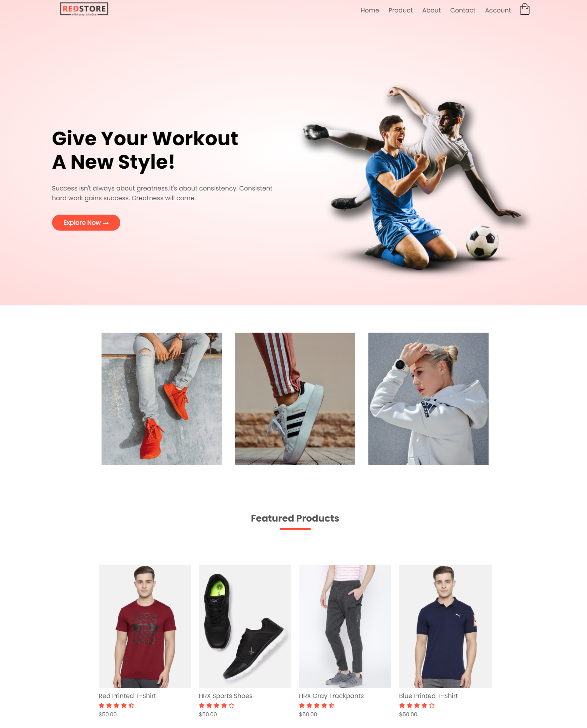

**Fig.1. Home page**

**Product**

A product page description is a type of marketing copy that describes your product in detail. It typically includes the product features and benefits, highlighting why a visitor should consider making a purchase. A good product description also includes specifications like shape, size, dimensions and other relevant parameters that can help the online shopper visualize the product better. If you strategically use keywords that describe the product or how a consumer searches for it, the search crawlers will make sure your page ranks better.

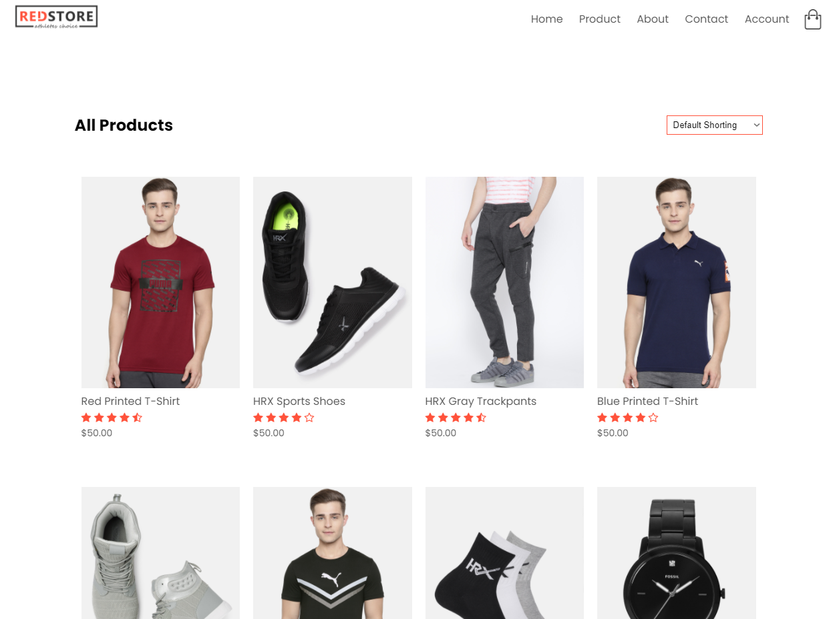

**Fig.2. Products**

**Product Detail**

**Title**– Main title for the product (e.g. Red T-Shirt)  
 **Brand**– Product Brand (e.g. puma)  
**Primary Image**– Default product image for main thumbnail on the product page  
 **Product Review Stars–** Average rating for the product (not seller) based on Amazon user reviews.  
 **Price-**Product Price from the seller featured on the Product page (e.g. $64.99 from NextGen Sports)  
**Color**– Color for the parent product on the product detail page (e.g Black). When shoppers select a variation (e.g. Red) on the main product page- that leads to a new product page, in the example below that would be for the Red t-shirt.  
**Variation options**– Child variations available for the main product. Such as color, material, etc.  
**Size–** Size of the parent product (e.g. 50-ounce, medium)

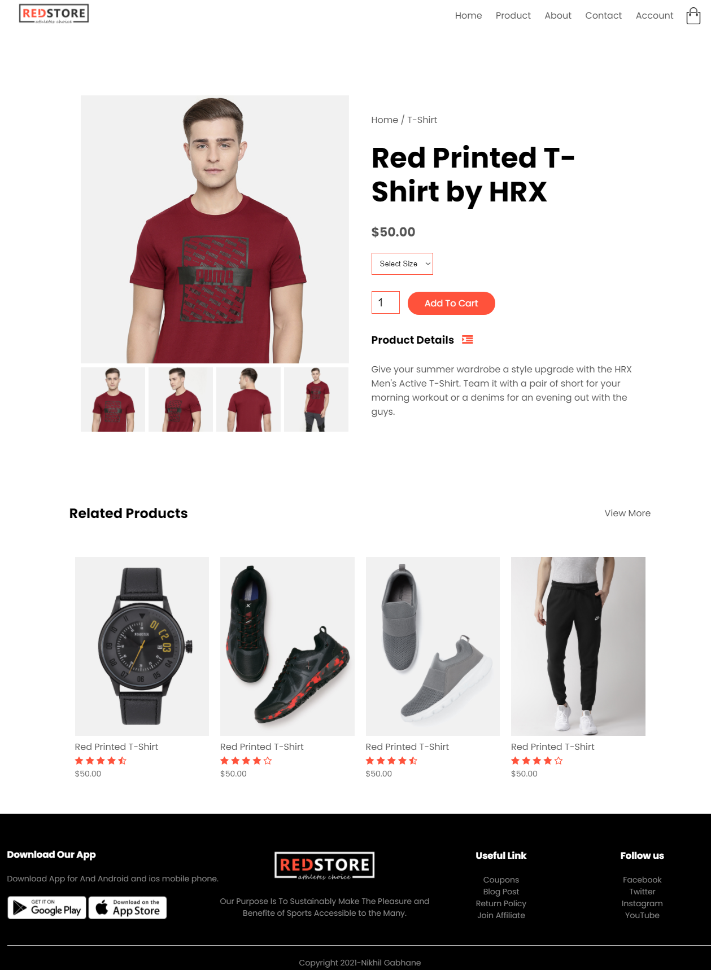

**Fig.3. Product Detail page**

**Login Module**

The user can login to the website by authenticating him/her self-using E-mail id and password in successfully they can access the online website.

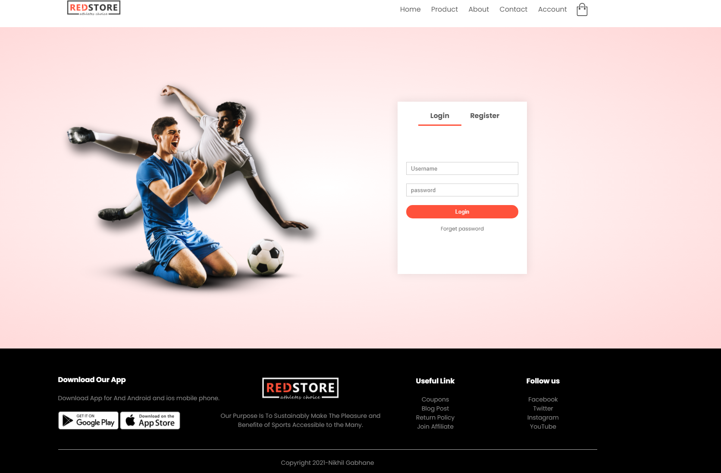

**Fig. 4. Login page**

**Register Module**

The new user can create an account by registering on to the website this module store the information provided by user into the database and this information is used to authenticate the user.

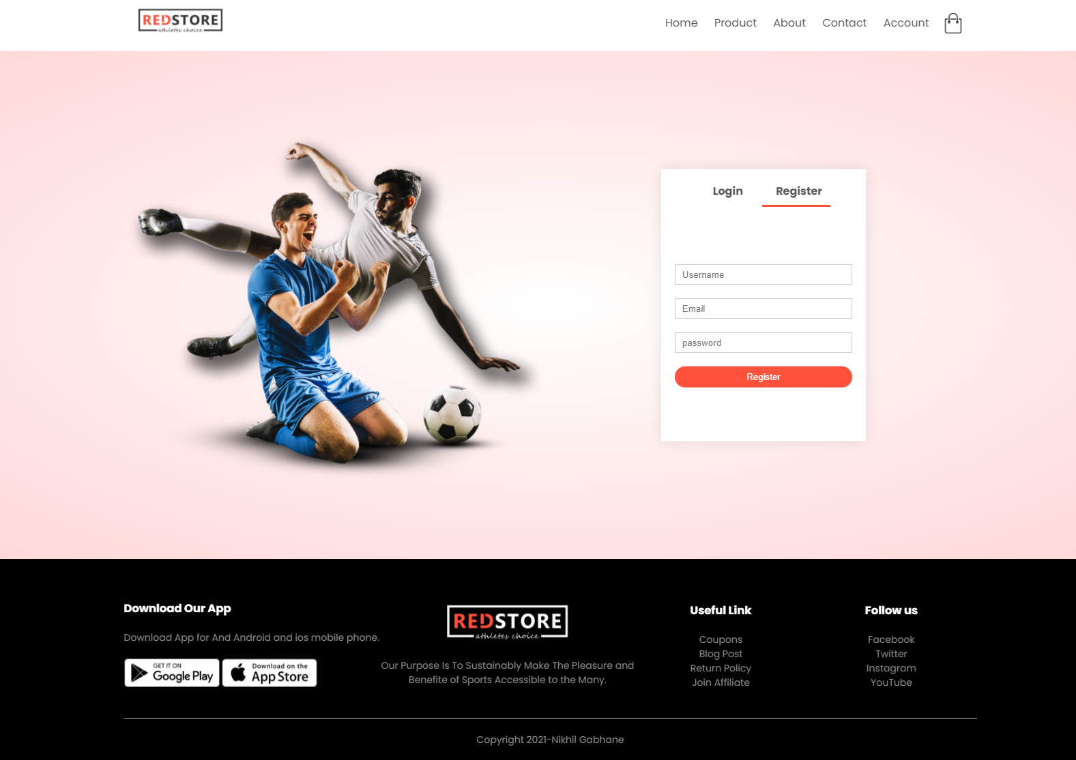

**Fig. 5. Register page**

**Cart Module**

Users can visit the cart page on the e-commerce website they are shopping from and see all the items they chose to buy. This page shows the individual prices of each of the products a user is buying, the quantity in which it is being bought, as well as the total amount of all the items being purchased. Customers can then proceed to checkout and receive a receipt of their payment via email.

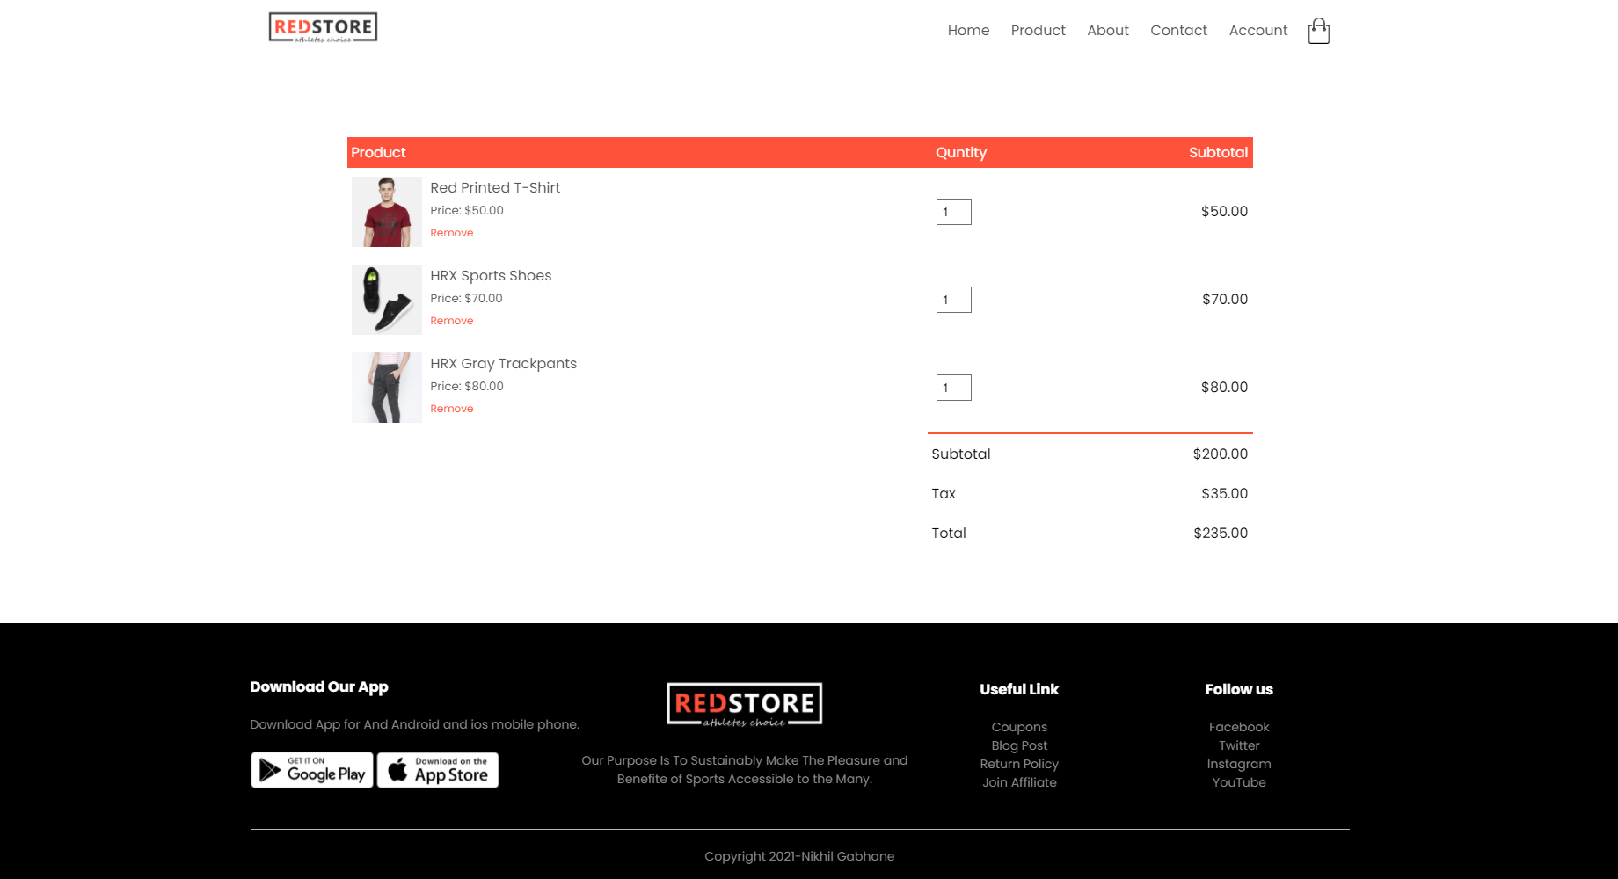

**Fig. 6. Cart page**

**Visual Studio code**

An HTML editor is program for editing HTML the mark-up language of a web page. Although the HTML mark-up in a web page can be controlled with any text editor specialized html editor can offer convenience and added functionality. for example, many html editor not only html but also related technologies such as css, html.

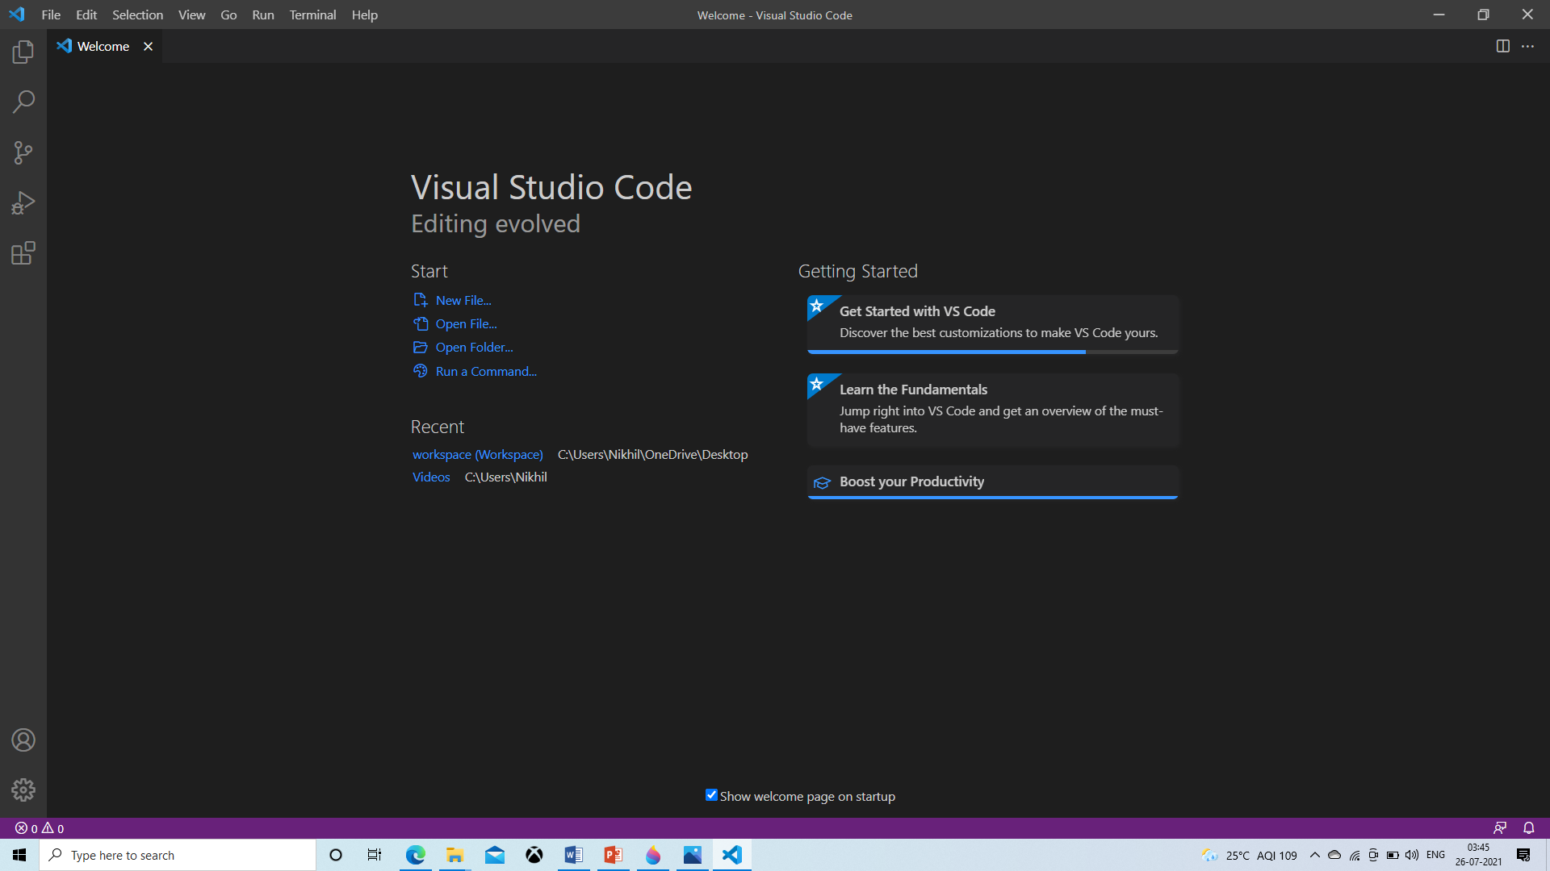

**Fig. 7. Visual Studio Code**

**6. Benefits of E-commerce**

The main benefit from the customers’ point of view is significant increase and saves of time and eases access from anywhere in the globe. Customer can place a purchase order at any time. The main benefits of e-commerce for customers are as follows:

* Reduced transaction costs for participating exchange in a market.
* Increased comfort - transactions can be made 24 hours a day, without requiring the physical interaction with the business organization
* Time saving- Customer can buy or sell any product at any time with the help of internet.
* Quick and continuous access to information Customer will have easier to access information check on different websites at the click of a button.
* Convenience-All the purchases and sales can be performed from the comfort sitting a home or working place or from the place a customer wants to.
* Switch to others companies-Customer can easily change the company at any time if the service of a company is not satisfactory.
* Customer can buy a product which is not available in the local or national market, which gives customer a wider range of access to product than before.
* A customer can put review comments about a product and can see what others are buying or see the review comments of other customers before making a final buy.

The main benefits of e-commerce from sellers’ point of view is increasing revenue and reducing operation and maintenance costs through internet. These include as follows:

* Increases revenue.
* Reduces operation and maintenance costs.
* Reduces purchase and procurement costs.
* Raises customer loyalty and retention.
* Reduces transportation costs.
* Develops customer and supplier relationships.
* Improves speed of the process of selling.
* Improves internal and external communication. and
* Develops the company image and brand.

**Conclusion**

This research paper provides insight into the development of e-commerce of website. While understanding the nitty gritties of its different aspects with special emphasis on B2C e-commerce. Which has shown tremendous growth in the recent years because of increased consumer awareness, investor trust and technological proliferation. The study has also produced certain trends and factors which shall propel further growth within the e-commerce market in India

E-Commerce has changed our life styles entirely because we do not have to spend time and money travelling to the market. It is one of the cheapest means of doing business as it is e-commerce development that has made it possible to reduce cost of promotion of products and services. There is no time barriers in selling the products. One can log on the internet even at midnight and can sell products at a single click of mouse. An interactive user friendly and focused website in the form of online shop can generate good business. So we are of the opinion that big companies should invest more on research and development for e-commerce. More benefits e- commerce websites in daily life our easy to buy into the products.

**References**

[1] Ruvalcaba, Z., & Boehm, A., “Introduction To The Web Development” in murach’s HTML5 and CSS3, 1sted., Fresno, CA: Mike Murach and Associates, Inc., 2012, pp. 4--7.

[2] Wikipedia

[3] Gupta, A. (2014, January). E-Commerce : Role Of ECommerce In Today's Business. International Journal of Computing and Corporate Research, 4(1).

[4] [Developing an E-commerce website | IEEE Conference Publication | IEEE Xplore](https://ieeexplore.ieee.org/document/7522526)